**Address Validation Usage Scenario Document for Microsoft Dynamics 365 Business Central**

Contents

**1.Introduction** 3

**2.Address Validation Setup** 3

**3.Functionality Test Cases for Address Validation** 4

**Sales Order** 4

**Purchase Order** 7

**Service Order** 10

# **1.Introduction**

**Validate (primarily US-American) your ship-to information in open document of SALES/PURCHASE/SERVICE documents**

Address Validation tool validates postal addresses from the UPS address book and gives the suggestions of ship-to information based upon below parameter.

* Address
* City,
* Zip (postal code),
* State

**Add-in capabilities**

When this add-in is used, it

* Can read the entered Ship-to address from the sales order page and suggest you the matching address which you can opt to update on the document.
* Can verify the address with the real time UPS address book and avoid entering wrong shipping address
* You can enable this functionality for Sales, Purchase and Service transaction and enable this add-in to suggest you the matching address.

# **2.Address Validation Setup**

User can easily enable or disable the Address Validation functionality from the Address Validation setup page.

Once user disable the address validation, no address validations action will not work from any of the pages.

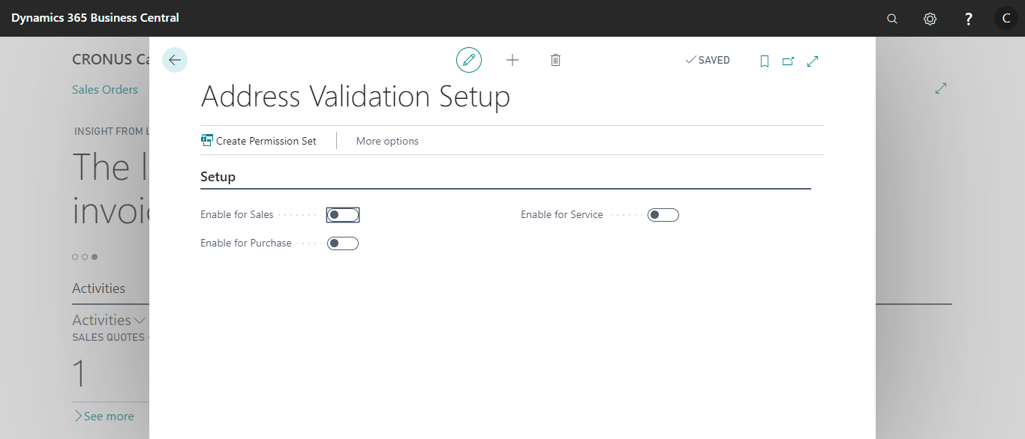

1. **Enable for Sales:** Enables the users to use the Address validation app for Sales documents
2. **Enable for Purchase:** Enables the users to use the Address validation app for Purchase documents
3. **Enable for Service:** Enables the users to use the Address validation app for Service documents

# **3.Functionality Test Cases for Address Validation**

This app covers the sales, Purchase and Service modules.

Below is the use case scenario for sales, purchase and service transaction.

## **Sales Order**

In the below scenario I am going to demonstrate how to get address suggestions using the “Address Validation app” for Sales order.

Search for the Sales Order list page

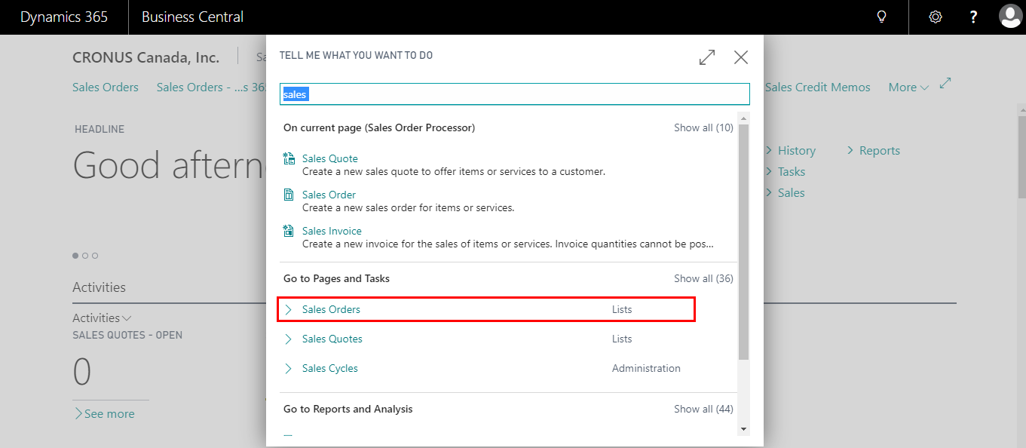

Select and open any sales order

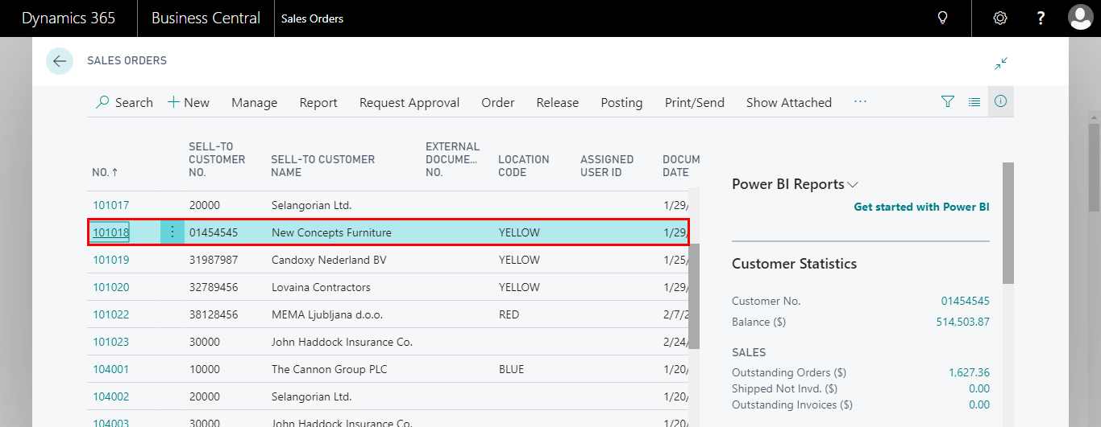

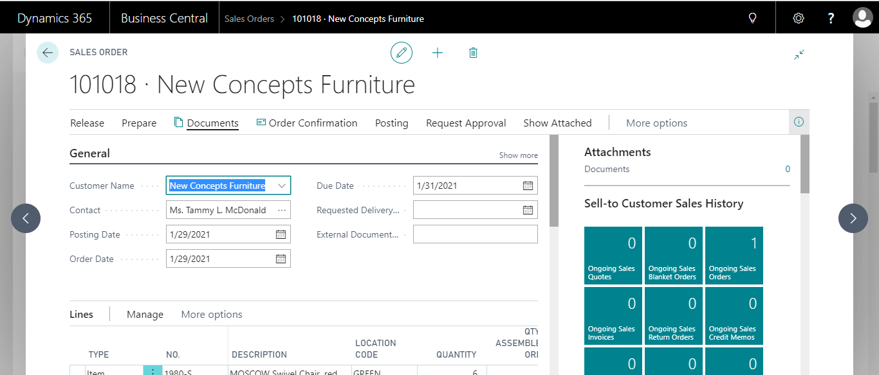

Navigate to **“Address Validation”** Action in the Action pane (shown in the below screen)

Click on the **“Address Validation”** action under the **Address Validation** action group

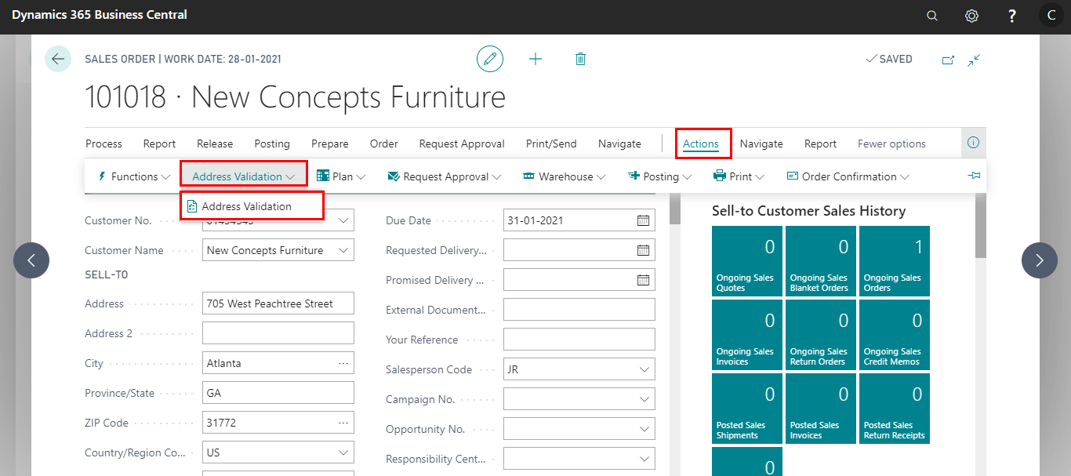

Based on the entered ship to address information If there is any Suggestions found in the UPS address book, it will open the **Address Suggestion List** page as shown below.

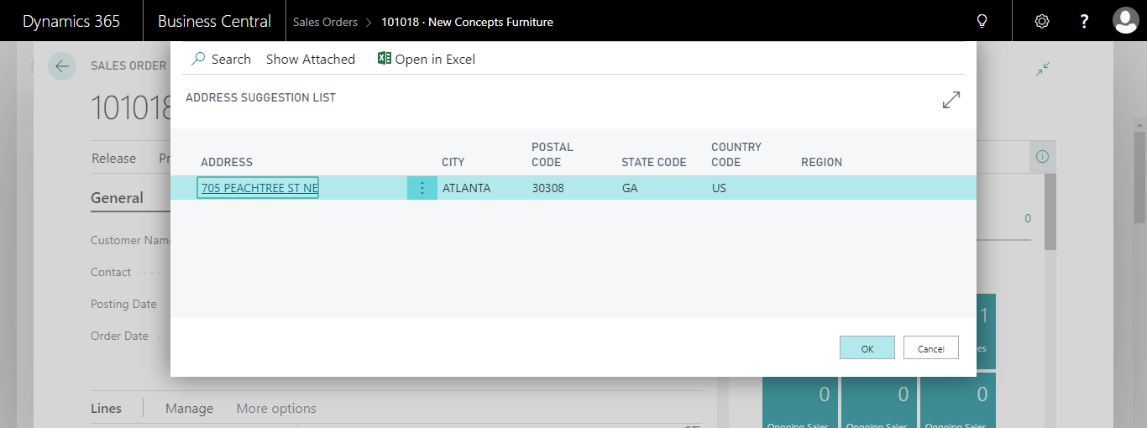

User will have choice to select the address from the **Address suggestion list** page and click on the **OK** button

After clicking on the **Ok** button, it will update the ship to address information from the selected address in the **Sales Order** page and if you click on cancel then it will ignore the suggestion and proceed with the entered address

Please see the below screenshots for before and after updating the Ship-to address information

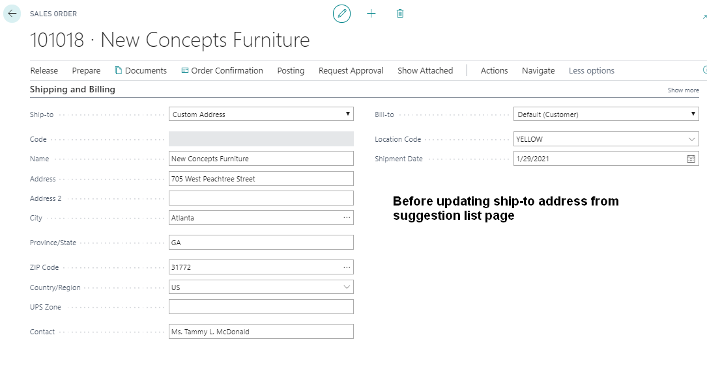

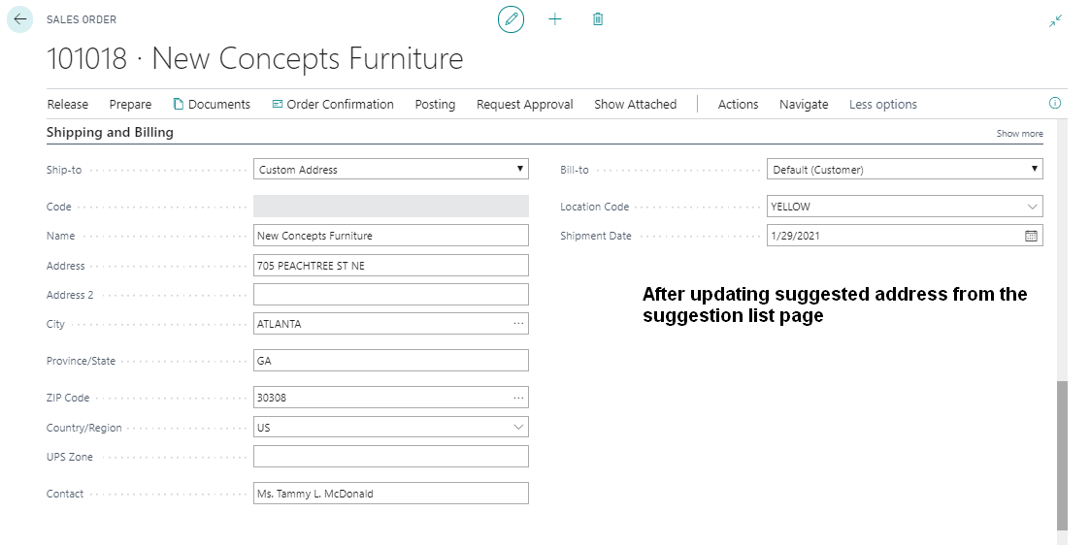

**Note: Same process applies for the Sales Quote, Sales Invoice documents.**

## **Purchase Order**

In the below scenario I am going to demonstrate how to get address suggestions using the “Address Validation app” for Purchase order.

Search for the Purchase Order list page

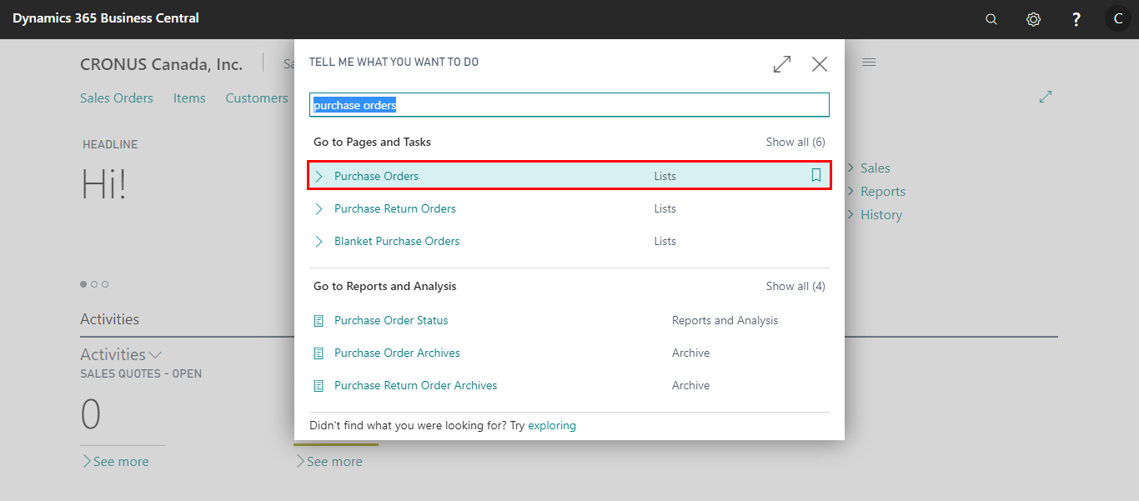

Select and open any Purchase order

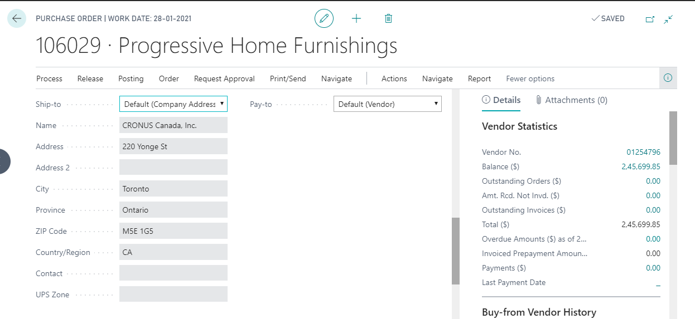

Navigate to **“Address Validation”** Action in the Action pane

Click on the **“Address Validation”** action under the **Address Validation** action group

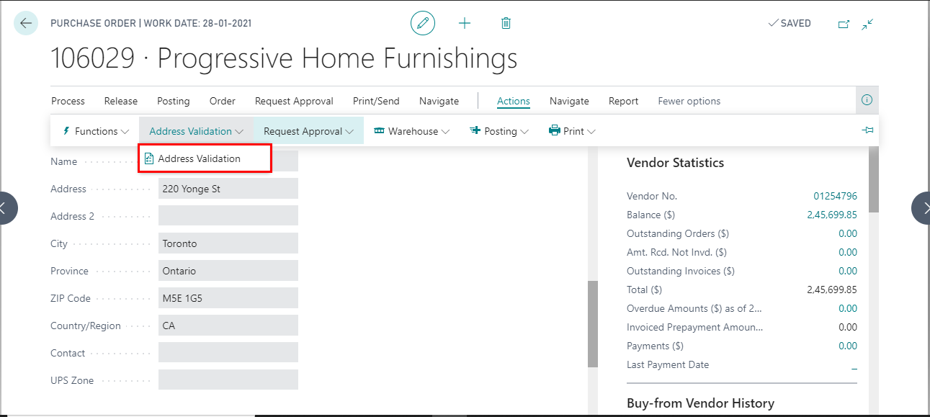

Based on the entered ship to address information If there is any Suggestions found in the UPS address book, it will open the **Address Suggestion List** page as shown below.

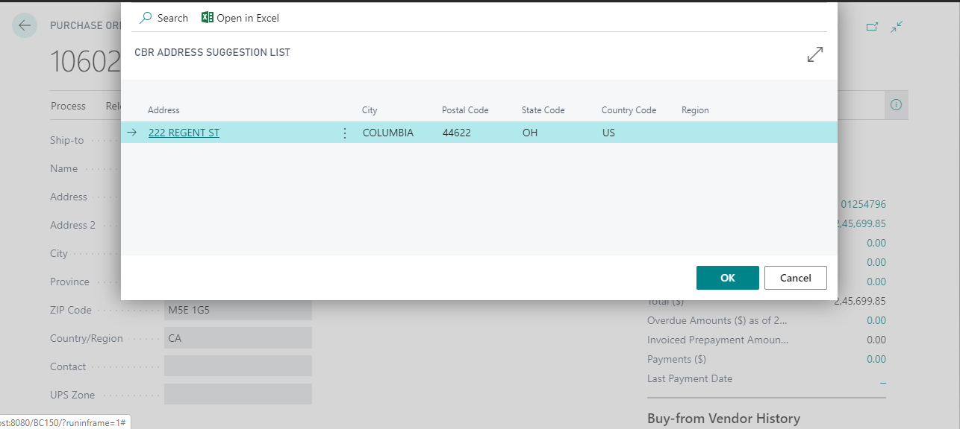

User will have choice to select the address from the **Address suggestion list** page and click on the **OK** button

After clicking on the **Ok** button, it will update the ship to address information from the selected address in the **Purchase Order** page and if you click on cancel then it will ignore the suggestion and proceed with the entered address

Please see the below screenshots for before and after updating the Ship-to address information

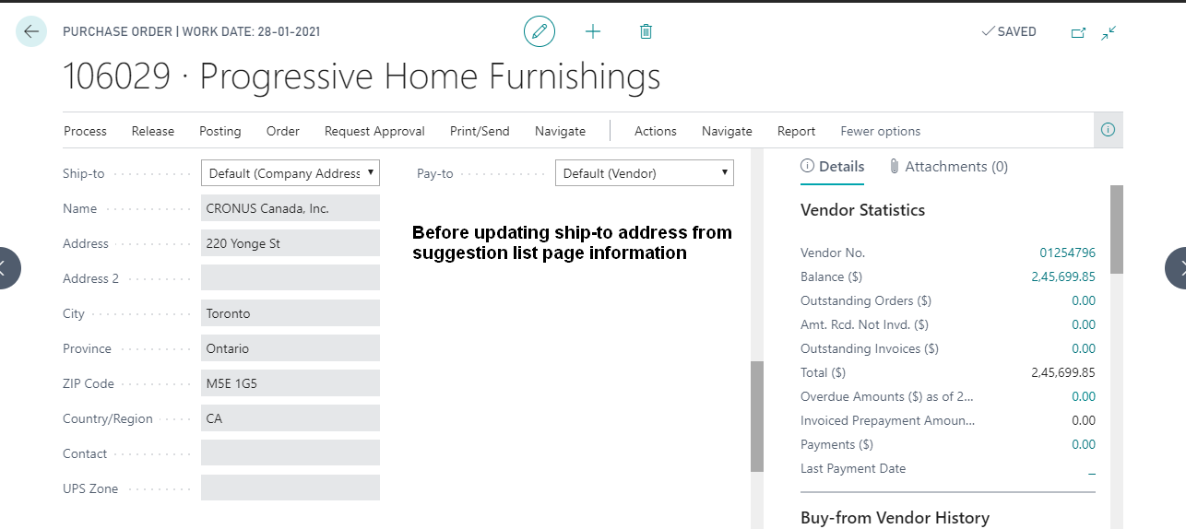

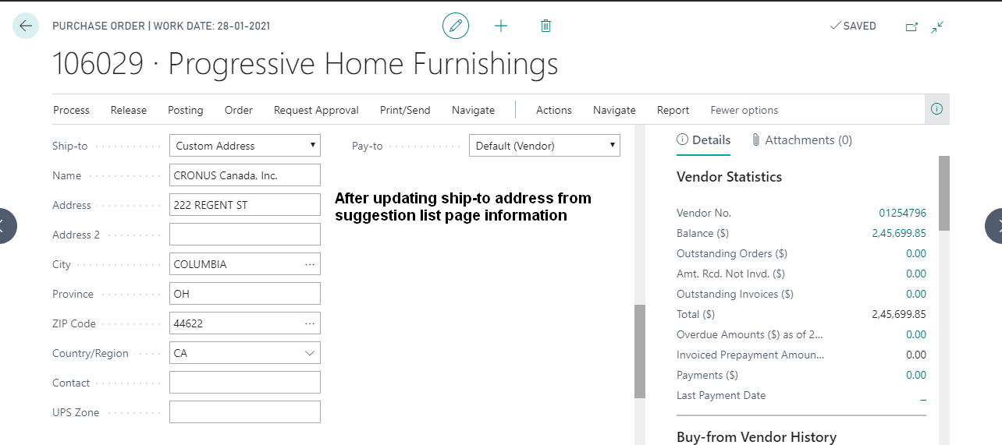

**Note: Same process applies for the Purchase Quote, Purchase Invoice documents.**

## **Service Order**

In the below scenario I am going to demonstrate how to get address suggestions using the “Address Validation app” for Service order.

Search for the Service Order list page

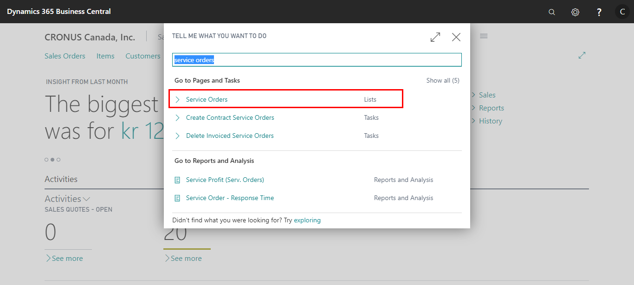

Select and open any Service order

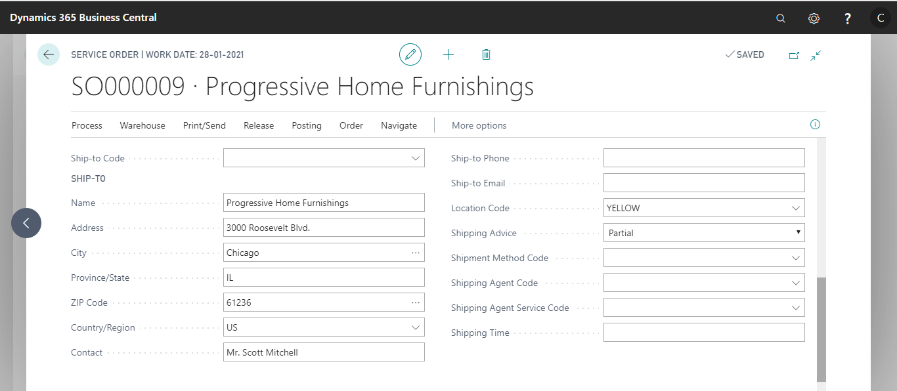

Navigate to **“Address Validation”** Action in the Action pane

Click on the **“Address Validation”** action under the **Address Validation** action group

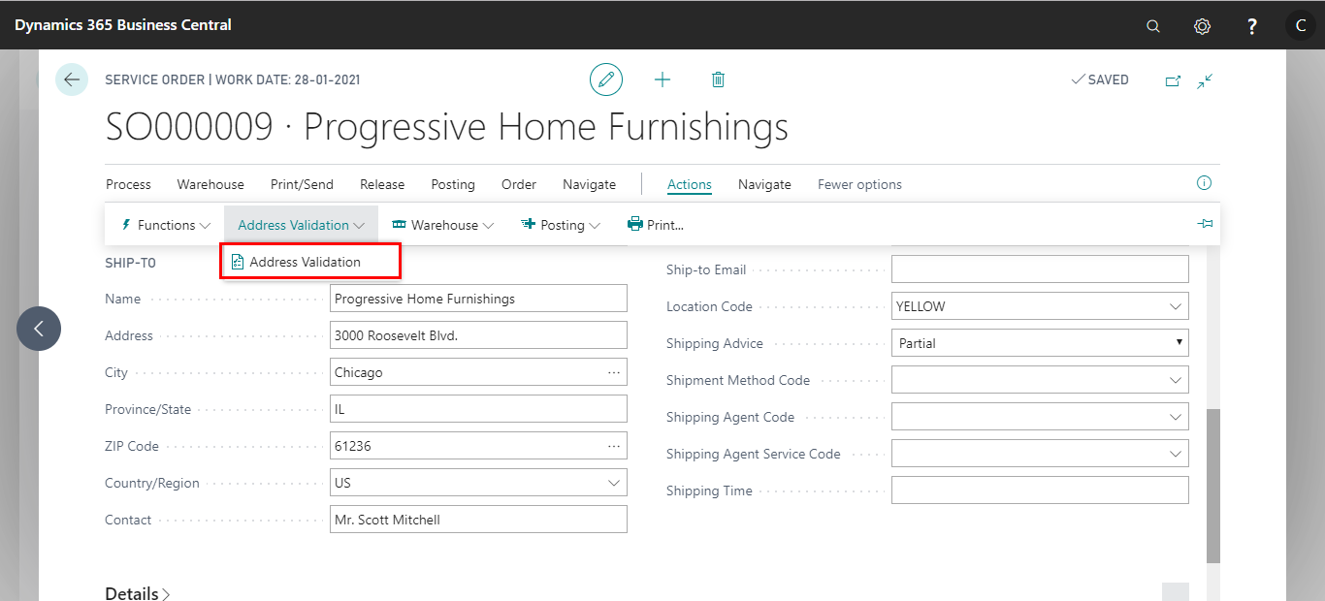

Based on the entered ship to address information If there is any Suggestions found in the UPS address book, it will open the **Address Suggestion List** page as shown below.

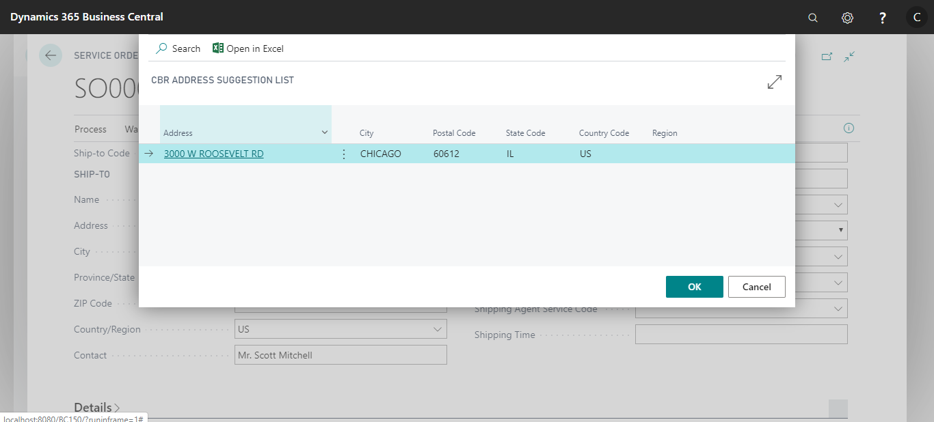

User will have choice to select the address from the **Address suggestion list** page and click on the **OK** button

After clicking on the **Ok** button, it will update the ship to address information from the selected address in the **Service Order** page and if you click on cancel then it will ignore the suggestion and proceed with the entered address.

Please see the below screenshots for before and after updating the Ship-to address information

Before updating ship-to address from suggestion list page information



After updating ship-to address from suggestion list page information

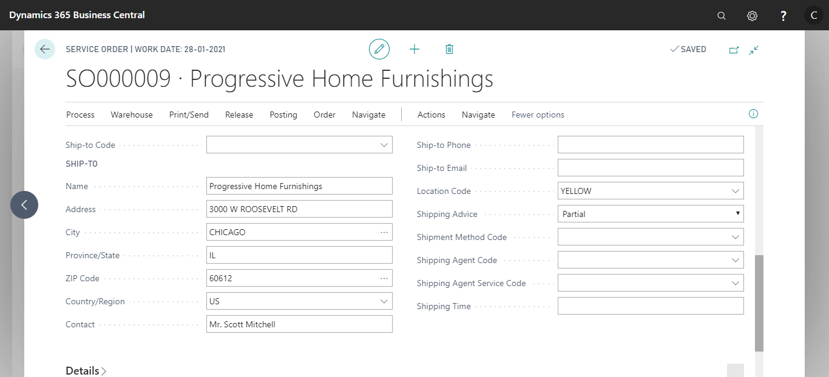

**Note: Same process applies for the Service Quote, Service Invoice documents.**